|  |
| --- |
| EXTERNAL VACANCY ANNOUNCEMENT |

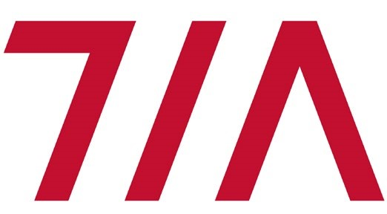

Tirana International Airport SHPK (TIA) is seeking to hire a

**SCREENING AGENT**

who will report to the **Screening Supervisor** of the company.

**Main tasks and responsibilities of the position:**

*(for indicative purposes only. The responsibilities listed below can be subject of change upon recruitment)*

* Responsible to conduct screening of passengers, baggage, cargo and mail consignments, and airport staff and visitors in compliance with TIA procedures, standards and specific instructions.
* Responsible to carry out risk assessments of passengers/staff/visitors and selects those requiring enhanced security screening.
* Responsible to instruct passengers/staff/visitors and ensure that baggage, electronic and electrical equipment (PC laptops, mobile phones, etc), baby strollers, child seats, etc, are properly placed in the feed belt for the X-ray equipment to guarantee effective image production. Prevents unsuitable items from being placed on the belt and stops machine if any item is being jammed or trapped.
* Responsible to operate the X-Ray machine within the standards of screening, and properly use all main image evaluation functions (brightness, contrast, inverse image displays, organic stripping, inorganic stripping and zoom functions, etc)
* Responsible to interpret the X-ray images produced by the X-ray equipment. Identifies hand bags that might contain a prohibited article (or any item that cannot be positively identified) for further processing by hand search and application of explosive trace technology. Pinpoints the shape, size, and location of potential concealed threats and shows the searcher the area of the hand bag that should be searched.
* Responsible to manually inspect items requiring additional processing after selection by the X-ray screener following correct search techniques and using explosive trace detection equipment (if available). Responds appropriately when prohibited articles are discovered and informs the screener of what the object was that caused the suspicion, once a search is completed.
* Responsible to direct and control the flow of passengers/staff/visitors through the Walk through Metal Detector (WTHMD). Monitors any alarms that are generated by the equipment and directs passengers/staff/visitors for secondary checks by performing a physical hand search. Uses explosive trace detection equipment during a random search

(if available).

* Responsible to screen hold baggage, cargo and mail consignments and interpret the X-ray images produced by the X-ray equipment. Identify dangerous objects in hold baggage, cargo and mail consignments and ensures that no prohibited items are inserted in them. If necessary, perform hand search.



|  |
| --- |
| EXTERNAL VACANCY ANNOUNCEMENT |



**Requirements of the position:**

* Bachelor Degree preferred
* Minimum age requirement 23 years old.
* Previous experience in security, military, police or customer care is preferred
* Accurate and skilled at inspecting
* Ability to strictly follow directions of superiors
* Ability to work effectively as part of a team
* Ability to work under stress and respond to emergencies
* Very good communication skills and customer-oriented mindset
* Intermediate level of English language

To apply for the above mentioned position the applicants should fulfill the Internal Application Form, which can be found in the Administration Building, Office Nr.101, and submit it together with a recent CV to the following address: human-resources@tirana-airport.com, or to the reception of the Administration Building (Rinas).

Human Resources Department will contact only candidates selected from the documentation screening.

